PRACTICAL NO :- 8.
Continuous Integration and Development Using Jenkins
Steps:
- Install Jenkins (visit https://www.jenkins.io/
- Install Jenkins (visit http://localhost:8081
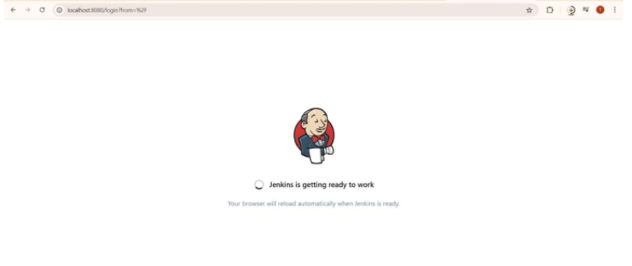

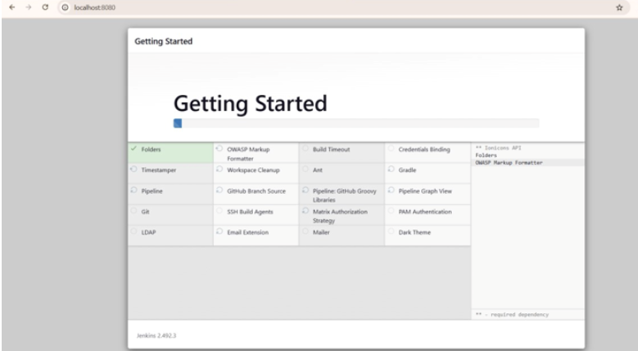

- Create new Freestyle Project: CI-Demo
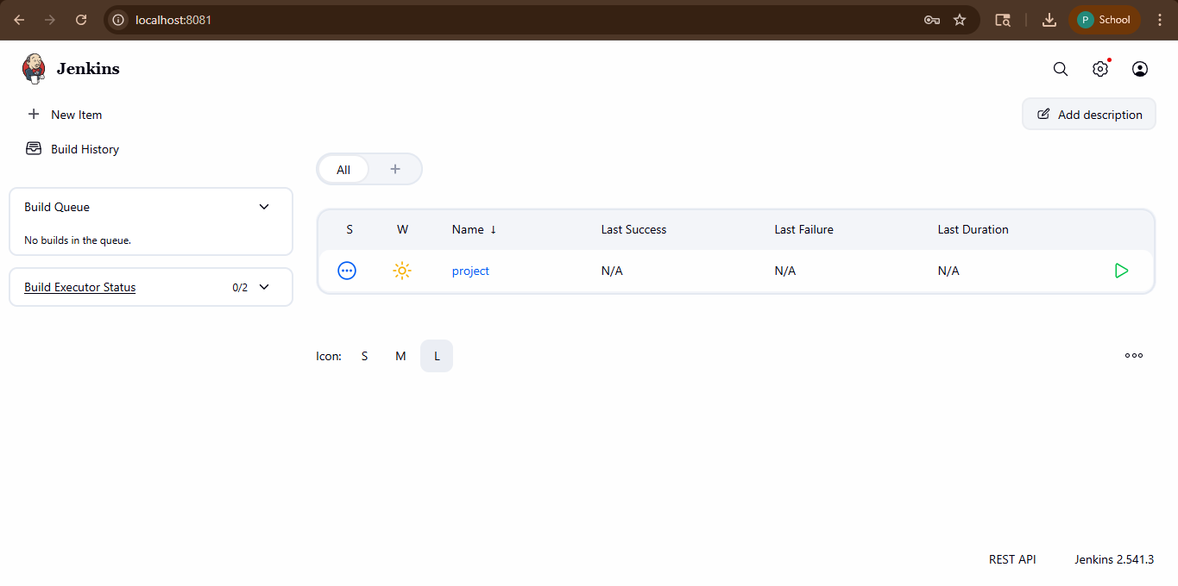
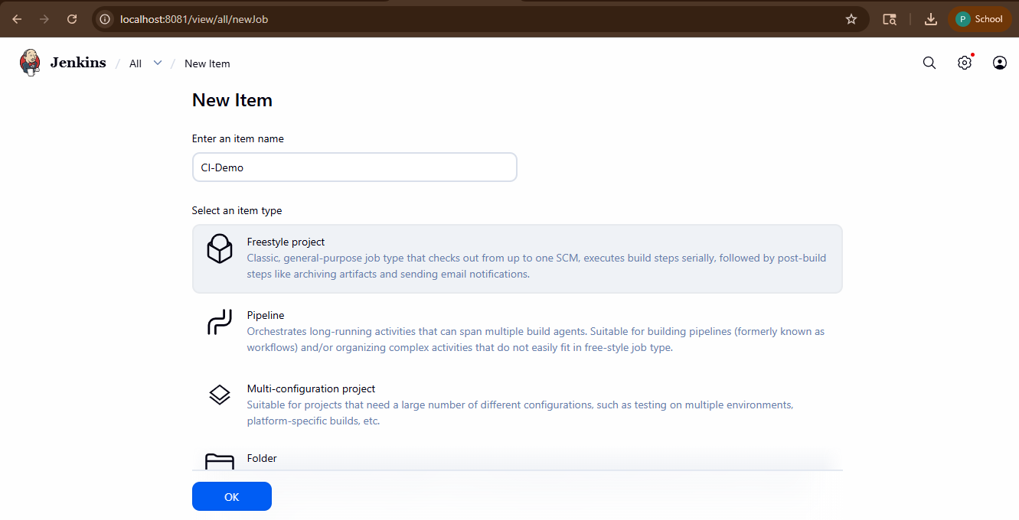
- Under Source Code Management, choose Git and enter your repo URL.

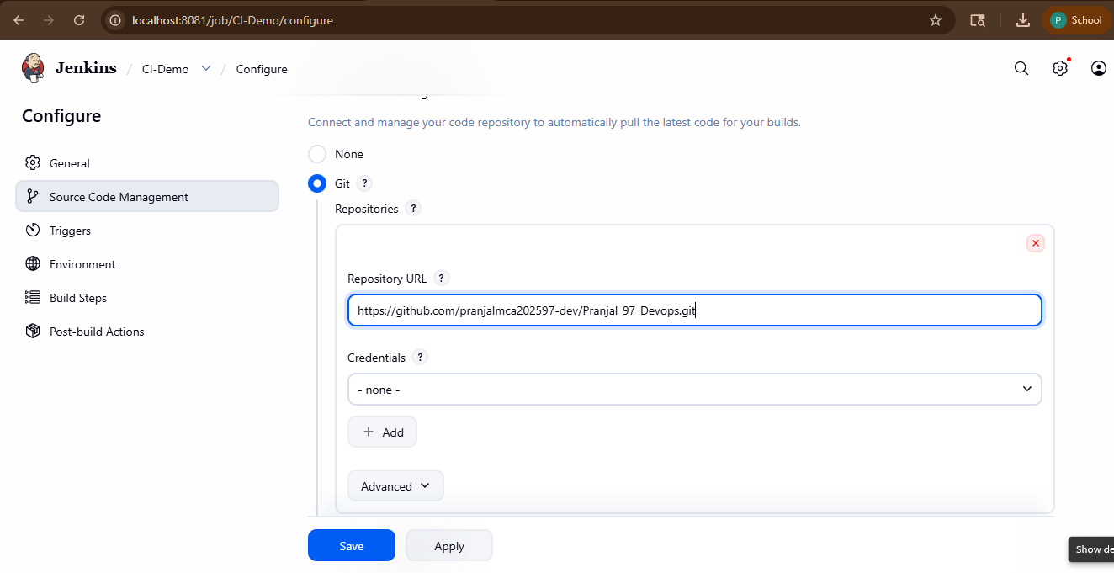

5. Add Build Step>Execute Shell:echo Building Project...echo Run tests...
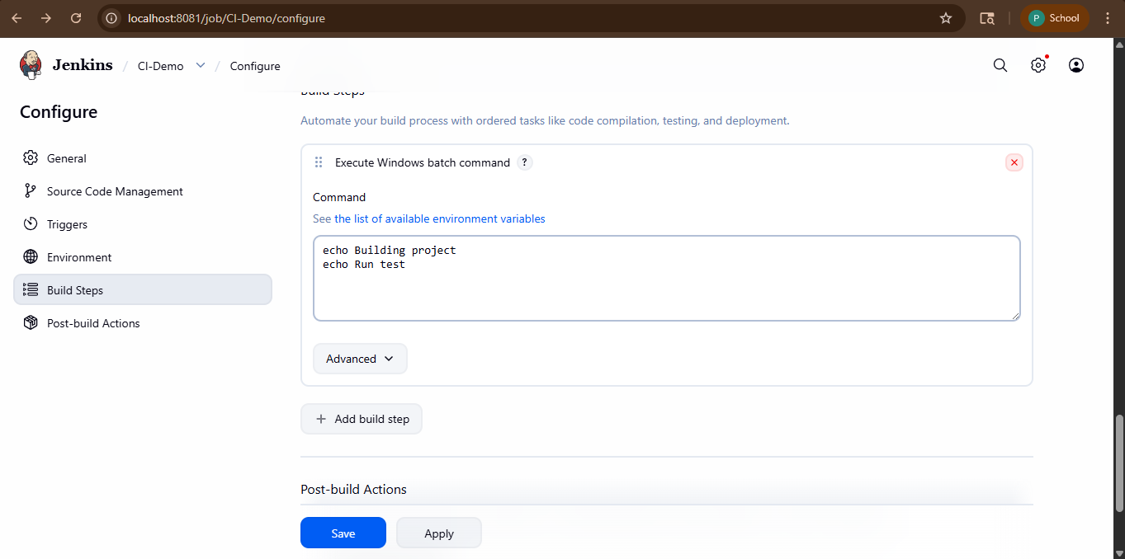
- Save and click Build Now.

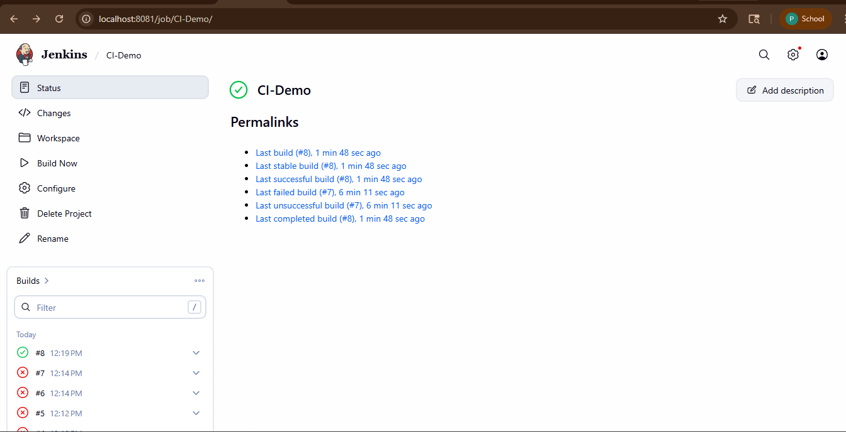
- Check output in Console Output.
